ANNAMACHARYA
INSTITUTE OF TECHNOLOGY & SCIENCES
(AUTONOMOUS)
New Boyanapalli, Rajampet Annamayya (Dist)– 516126

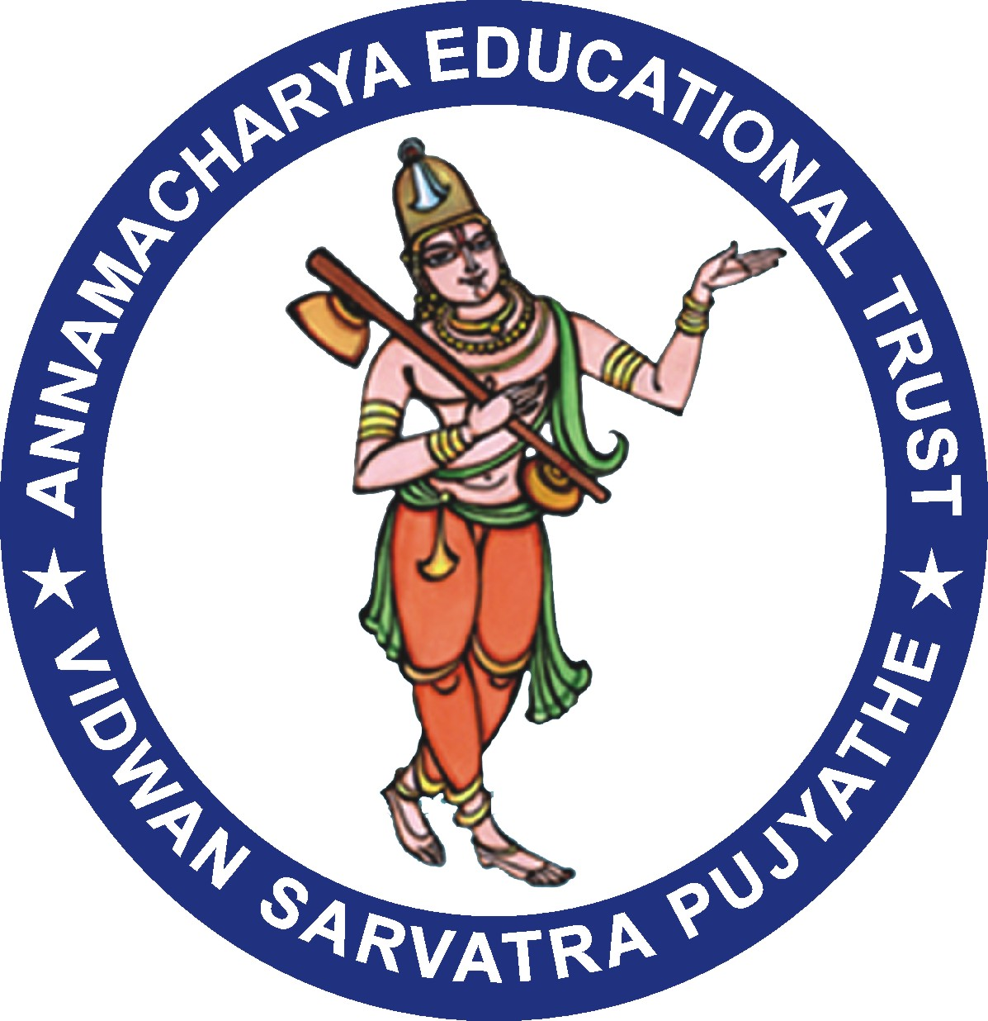

Department of Business Administration

Alumni Meeting Report – 2020

Virtual alumni meet was organized for the alumni of Department of MBA, AITS, Rajampet on 13th December, 2020. Mrs. V. Vedavathi, Department Alumni Coordinator welcomed the dignitaries and the participants in the virtual meet. She refreshed the memories and shared their active role of alumni in programs organized in the department.

This time due to COVID Pandemic situation the Alumni meeting is conducted in Online mode. Several points related to the academics of MBA and the suggestions received from the Alumni were discussed in this meeting. Since the meeting this time is on online mode many people attended the event from different places across the globe.

The virtual gathering was welcomed and addressed by Dr SMV Narayana garu, Principal of AITS, and Head of the Department, Dr. P. Subramanyam who shared their views about the importance of alumni meet and enlightened students with his views. They stressed on the importance of dedication and persistence in gaining success in carrier.

Dr. T. Navaneetha, Assistant Professor and Alumni of MBA department, emphasized on the role of alumni in strengthening the department and stressed on building of strong bonding between juniors and the seniors for overall growth of the department. Alumni showed their solidarity in helping the students pursuing course in the department with guidance in carrier prospects. The session progressed with sharing of various experiences. Alumni who were attended to the meetings were expressed their happiness and Satisfaction towards the alumni activities.

Suggestions by the Alumni

- Suggested to have an offline visit by alumni after the pandemic period
- Suggested to introduce Business Analytics programme in MBA curriculum in the institute.
- Suggested to implement advanced courses in the curriculum
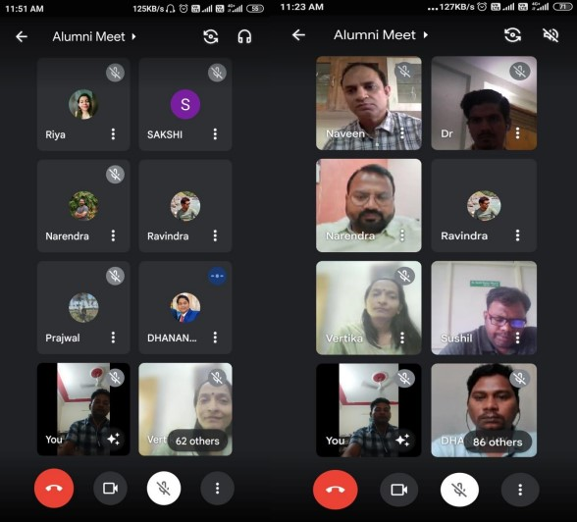
(Virtual Alumni Meet on 13th December, 2020.)
Alumni Invitation Link:
Meeting Link: https://meet.google.com/buk-opae-fzv
V. Mouneswari, Assistant Professor and Alumni, Department of MBA placed on record the formal vote of thanks. All the participants attended the alumni meet with great enthusiasm and made the alumni meet a great success with exchange of thoughts and ideas.

Department Alumni Coordinator

