**IndIan InstItute of management**

**Annamacharya  
Institute of Technology & Sciences (Autonomous): Rajampet**



**Communication and**

**Presentation skills**

**Programme Director:**

**Mrs.V. Mouneswari**

**Programme Dates:**

**8th Feb 2021 to 10th Feb 2021**

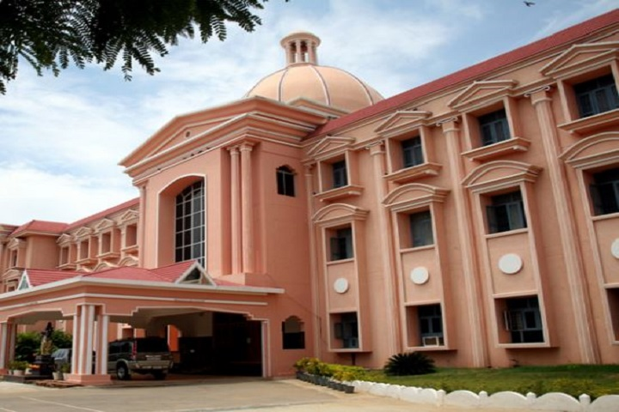

**Programme Venue:**

**AITS MBA SEMINAR HALL**



**PEDAGOGY**

The Programme will be highly experiential and interactive, comprising of individual and group exercises, role plays,

participant presentations and discussion.

**WHO MAY ATTEND**

The Programme is recommended for managers at all levels and from all functional areas.

A varied cross section of participant profiles adds new dimensions and perspectives to the discussions and experiential

sessions.

**KEY TOPICS**

•

Communication Skills

•

Interpersonal Communication

•

Oral Presentations

•

Audio Visual Presentations

•

Written Communication

•

Persuasion

•

Leadership Communication

•

Cross-Cultural Communication

**Programme Director**

**Mrs.V. Mouneswari**

has been teaching Managerial Communication and has versatile knowledge in Managerial concepts.

She has delivered various lectures on communication skills to PG students in order to enhance their communication skills.

Her major focus is on participant centred learning.

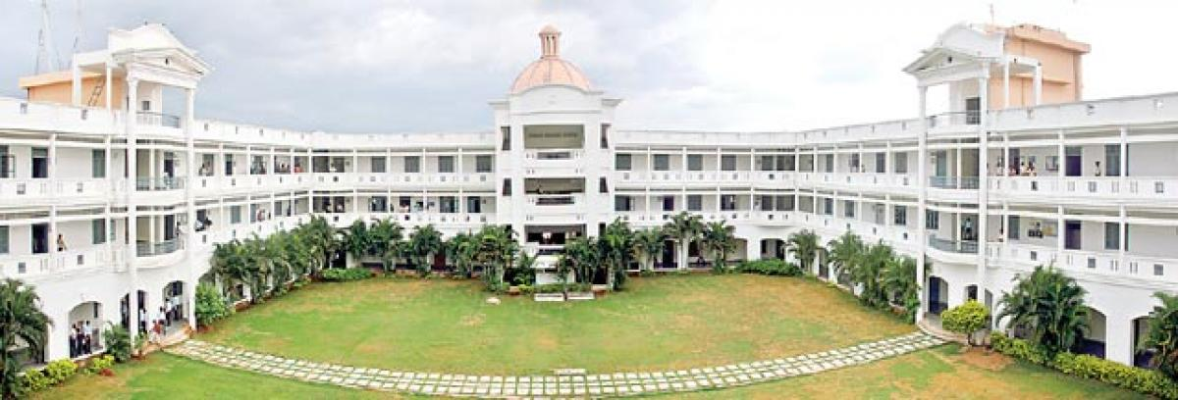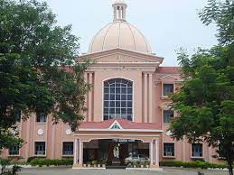

**INTRODUCTION**

Effective oral and written communication skills have frequently been identified as prerequisites to managerial success.

Research on recruiter’s perceptions about the qualities that they look for in an applicant, have identified oral and written

communication skills at the top of their list (Powell & Jankovich, 1998: Moody, Stewart & Boltlee, 2002). This is not

surprising considering that managers are frequently required to make presentations both within the organisation and to

external groups such as clients, or potential partners. The purpose or intent of these presentations may vary from sharing

information to persuading the audience or selling an idea or product. In each case an effective presentation will aid the

communicator in performing his/her role.

Moreover, in the current environment, individuals increasingly face an information overload and shorter time spans within

which they are required to assimilate data and make effective and informed decisions. In such a scenario the ability to

communicate is imperative for managerial effectiveness and success. In this context the MDP on Communication and

Presentation Skills will highlight some issues that a communicator should consider in order to make effective written and

oral presentation.

**OBJECTIVES**

To help participants to examine their communication styles and to hone their skills in listening, responding, giving and

receiving feedback and persuasion. To practice and enhance written and oral communication skills.

**Programme Details**

**Duration:**

February 08th TO 10th 2021

**Programme Commencement:**

9:30 AM on February 08, 2021

**Programme Conclusion:**

2:00 PM on February 10, 2021

**Venue:**

AITS MBA Seminar Hall

**Accommodation:**

For Residential participants

**Check in:**

February 07, 2021 (6:00 pm onward)

**Check out:**

February 10, 2021 (2:00 pm)

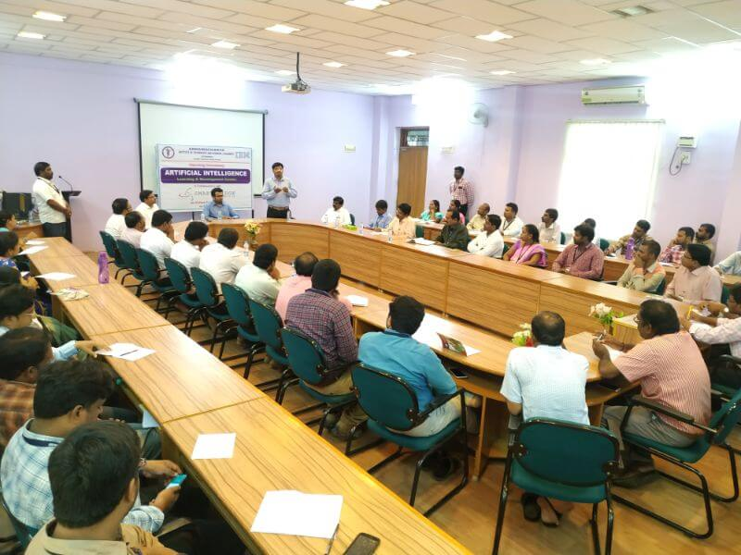

**Programme fees**

**Residential (R):**

`

Rs. 3,500

**Non-Residential (NR):**

`

Rs.2000

We would strongly encourage candidates to enroll as Residential participants, as the experience of an MDP is optimized in

a full-immersion mode.

**Discount on Programme fees:**

A discount of 10% on the Programme fees can be availed by an organization if it nominates at least 4 participants for a

particular MDP.

**Terms & Conditions**

•

Participants would have to make their own travel arrangements.

•

Accommodation at Hotel Unique Stays, Rajampet will be Provided to all the participants. Participants staying beyond the

time will have to bear additional stay and food charges, which they have to settle directly with the hospitality service provider,

conditional upon room availability.

•

Cancellation Policy: In case you/your nominated candidate(s) does(do) not attend the programme, 40% of the programme

fees will be retained.

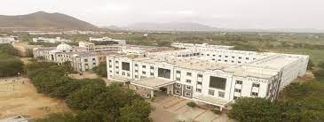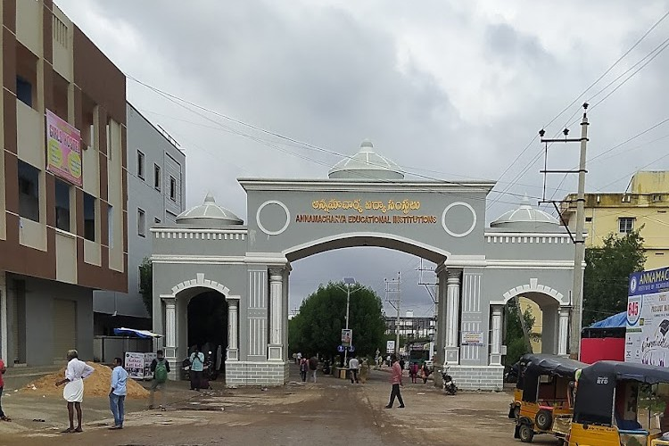

AITS Office

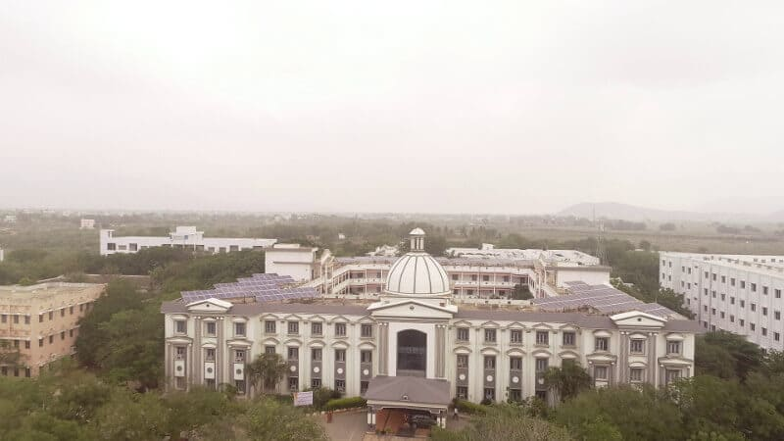

**Our correspondence address is as follows:**

Annamacharya Institute of Technology & Sciences (Autonomous)

New Boyanapalli, Rajampet, Kadapa (District) Andhra Pradesh

Phone: +251863/251864

[www.aitsrajampat.ac.in](http://www.aitsrajampat.ac.in/) Pin Co: 516126



# For further Clarifications, contact:

Mrs.V.Mouneswari, Program Coordinator, Phone number: 9515337737

email id: [cpsaits@gmail.com](mailto:cpsaits@gmail.com)