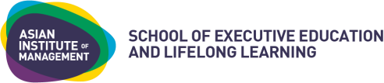
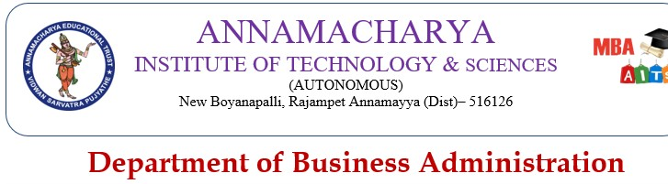
FOR INQUIRIES:
School of Executive Education and Lifelong Learning, Asian Institute of Management Eugenio Lopez Foundation Building, Joseph R. McMicking Campus
123 Paseo de Roxas, Makati City Philippines 1229 SEELL@aim.edu | +632 8892 4011 | www.aim.edu

Executive Assistant
Development Program

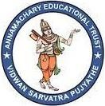
Program Schedule

August 16,17, 19 2022
09:30 AM to 4:00 PM
PROGRAM FEE
Rs 3000 Only

YOUR PROGRAM FACULTY
Dr. T. Navaneetha Associate Professor Department of
Business Administration, AITS

visit www.aitsrajampet.ac.in

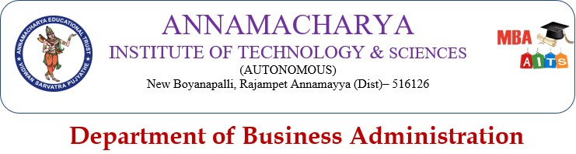

Executive Assistant Development Program
Become a Topnotch Administrative Professional to Contribute and Add Value to the Organization
OVERVIEW

High-performing executives in the Volatile, Uncertain, Complex, and ambiguous environment recognize the reality that a critical component to the success of any company is anchored on management's ability to get more done in the day-to-day operations and strategy implementation. Administrative nightmares are some other things that keep many executives awake at night. These issues include not having a strong business process flow that can be communicated and aligned across the company and having a workforce that is disconnected from the company due to that lack of alignment, making them indifferent about the company's priorities or, worse, highly demotivated.
With the increasing demands of day-to-day involvement, the engagement of the executives with the rest of the team is crucial to producing the expected business outcome for the organization. Hence, their productivity and effectiveness are hinged highly on how their work meetings, strategic priorities, and functional deliverables are structured efficiently.
This organizational challenge is where the Executive Assistant (EA) or Department Secretary can add value to the Executives they are supporting. The role involves performing not only primary office duties such as managing schedules an calendars, coordinating travel plans and itineraries, and attending meetings an taking minutes, but also project management of critical priorities for the executives, excellence in execution, overseeing the office or department budget managing correspondences and writing reports, and developing programs to improve the productivity of the office and interactions between departments an demonstrating leadership in areas where they can add value to the company.
A topnotch EA works with the organization's leaders to proactively look for ways to improve the organization's processes, systems, procedures, and colleague interactions. This is because they see the day-to-day details and complexities of the organizational priorities, which makes them uniquely equipped to know where the pain points are and, more importantly where there are opportunities for improvement
Experienced EAs may even have the opportunity to be the source of institutional memory about stakeholders, business partners, and organization challenges that will be helpful for new leaders to step into their roles. Not only do these management practices and best practices save vast amounts of time, but they also inherently make the life of busy executives easy and productive.
t
n

PROGRAM OBJECTIVES
At the end of the Program, participants will
- Establish appreciation of a topnotch Executive assistant's different roles in process improvement, team communication and engagement, project management, and customer service.
- Gain knowledge and understanding of various concepts and frameworks necessary to think critically, communicate effectively and manage work priorities efficiently.
- Learn best practices in addressing everyday challenges and hurdles from co-participants in the same role.

WHAT YOU WILL LEARN
- Stages of Contribution and The Role and Qualities of a Topnotch Executive Assistant
- Emotional Intelligence and Interpersonal Skills
- Effective Communication and Presentation
- Planning, Work Organization and Time Management
- Critical Thinking and Problem Solving
- Continuous Process Improvement
- Introduction to Project Management
- Excellent Customer Orientation
- Leadership Development Training and Workshop

The program will be capped by program graduation, oath-taking as AIM alumni, and Secretary's Week Celebration.

KEY BENEFITS

Well-Structured Program and World-Class Faculty
The offline program offers a venue for high impact learning with rea-l time, experiential, and interactive online sessions. The participants will learn from experienced faculty.

Enhanced Management Skills and Leadership Capabilities

The program develops topnotch Administrative Professionals with enhanced leadership capabilities, critical thinking, process improvement, stakeholder management, communication, knowledge of key people and management systems, and critical skill for transforming organizations and leading a diverse and multi-generational team.

Learning Content
The 3 Day program will cover the following topics:

Continuous Process Improvement
Day 2
Emotional Intelligence and Interpersonal Skills

Introduction to Project Management
Day 3
Effective Communication and Presentation

Excellent
Customer
Orientation

Planning, Work Organization and Time Management
Day 1
Stages of Contribution

The Role and Qualities of a Topnotch Executive Assistant
Leadership Development Training Workshop

WHO SHOULD ATTEND
The program is recommended for executive assistants, administrative assistants, department secretaries, and those who would like to pursue professional administrative assistant roles in the future. The program will benefit those who want to be more effective in their critical thinking, communication, work organization, project management, networking, and stakeholder
management and develop leadership skills for future growth in the organization.

Your Program Faculty

Dr.P. Subramanyam
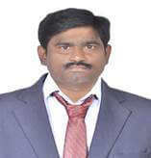
Professor & HOD
AITS, Rajampet
Dr.P.Subramanyam has done his Ph.D from Sri Venkateswara University. He has published 24 research papers in various National and International Journals. He has 13 years’ experience in Research and Teaching. He has authored 3 text books. He has attended Various National and International conferences. He acted as a Resource person for various Management events.

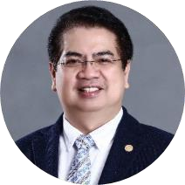
Dr.V.Mouneswari
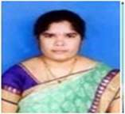
Assistant Professor
AITS, Rajampet
Dr.Mouneswari. has done Ph.D from Jawaharlal Technological Technological University, Ananthapuram. She is a seasoned business leader, educator, and motivator. She has 11 years of progressive experience in the fields of general management, finance, human resources, and management education. She is currently working in MBA Department as Assistant Professor and focusing on the serving the needs of Management students.

k. Subba Reddy
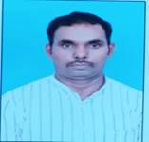
Assistant Professor
AITS, Rajampet
Subba Reddy is a seasoned Finance advisor, educator, and motivator. He has 16 years of progressive experience in the fields of finance and management education. He is currently working in MBA Department as Assistant Professor and focusing on the educating the students and executives across the World on various Financial aspects.

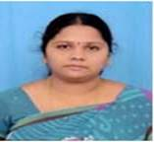
V Vedavathi
Assistant Professor
AITS, Rajampet
Vedavathi is an Assistant Professor at the Institute. She holds a Master of Business Administration from Annamacharya PG College of Computer Studies. She is knowledgeable in delivering Entrepreneurial suggestions for various Stakeholders. She is efficient in brainstorming the executives about Startup ideas and Problem Solving at work place.

A Anjanaiah

Assistant Professor
AITS, Rajampet
A. Anjanaiah is a coach, consultant, trainer, leader and mentor of continuous improvement for many years across various institutes in various fields. Presently he is associated with the institute and working with various companies on placement enrichment and in conducting campus recruitment trainings to the students.

O Pavithra
Assistant Professor
AITS, Rajampet
O. Pavithra is a coach and Motivator. She is very enthusiastic towards conducting various Personality Development Programmes at the Institute as well as outside the Organization. She is currently associated with the organization and conducting various management events for the development of Managerial skills of the students.

EARNING CREDENTIALS
Successful completion of the Program:
- Enhances the skills of Executives.
- Develops Managerial capabilities.
- Earns a Valuable Certificate from the Institute.

