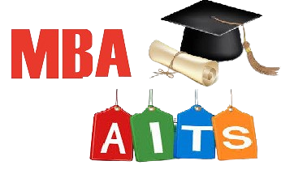
ANNAMACHARYA
INSTITUTE OF TECHNOLOGY & SCIENCES
(AUTONOMOUS)
New Boyanapalli, Rajampet Annamayya (Dist)– 516126

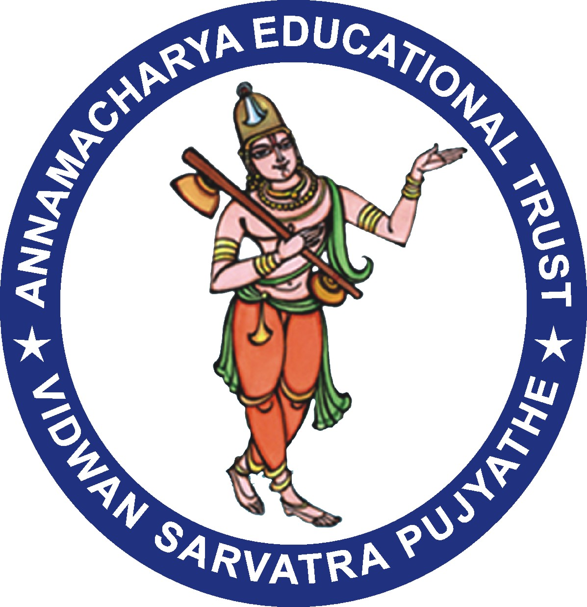

Department of Business Administration

Date: 20/07/2022
Circular
It is informed to all the Faculty members that Alumni Meet 2022 will be held on 11/12/2022 in AITS Main block from 2:00P M onwards. All the faculty members are here by requested to attend the meeting without fail.

Head of the Department.

ANNAMACHARYA
INSTITUTE OF TECHNOLOGY & SCIENCES
(AUTONOMOUS)
New Boyanapalli, Rajampet Annamayya (Dist)– 516126

Department of Business Administration

Alumni Meeting Report - 2022

Annamacharya Institute of Technology and Sciences, (AITS Alumni Association) has organized “Alumni Meet – 2022” on 11th December 2020 in the forenoon session. In the afternoon session Department of Business Administration has hosted “Departmental Alumni Meet – 2022”, at AITS Gallery. The inauguration function started with the lighting of the lamp by the dignitaries on the dais and Dr. P. Subramanyam, HOD of MBA Department welcomed all the members of AITS MBA Alumni Association.

Mrs. V. Vedavathi, MBA Department Alumni Coordinator has presented the activities initiated and executed in the department during the academic year 2021-22. She has presented the opinions expressed by the alumni members in previous annual meet of Alumni which is held on 12th December, 2021. A total of 37 Alumni attended to the Annual Alumni meet 2022 at AITS Rajampet.

The followed by interaction with alumni on topics like the importance of alumni network and the latest trends in job requirement. It was a great moment for the students of The Department of Business Administration to meet and share experiences of Alumnae of the college. This meet helped the students to visualize their role in the corporate world.
Dr. SMV Narayana garu Principal of the college delivered a key note address. I his speech he appreciated the alumnus for the career success and insisted the alumnus for facilitating on industry interaction, leadership, making inspiration among budding engineers and managers and guide the juniors for project and placements. Alumnus should provide and help our college to enhance

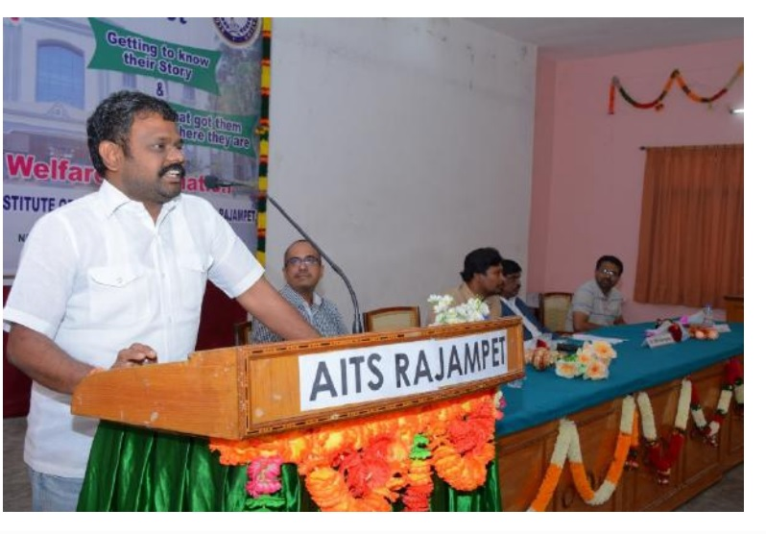

(Alumni Meet on 11th December 2022)

Suggestions by the Alumni

- Enhancing support for aspiring business owners like incubators, startups or Entrepreneurship focused courses.
- Provide easy access to online resources and webinars to the students for continue learning and updated on industry trends.
- Provide live technical sessions on stock market.
- Organize industrial tour to visit various production departments.
- Conduct industrial expert talks with industry experts

The AITS MBA alumni Association sincerely expressed its gratitude and acknowledgement to AITS management, Principal, HOD of MBA, Teaching and Non-teaching staff for guidance, support to successfully conduct in Alumni Meet.

Outcome:
The alumni have decided to organize the more interactive events other than Alumni Meet to strengthen the relation between alumni and their juniors. Industry alumni are invited and share their industrial exposure to enhance the soft skills, managerial skills and core competency of knowledge of students for the department through the AITS placement cell.

Department Alumni Coordinator

