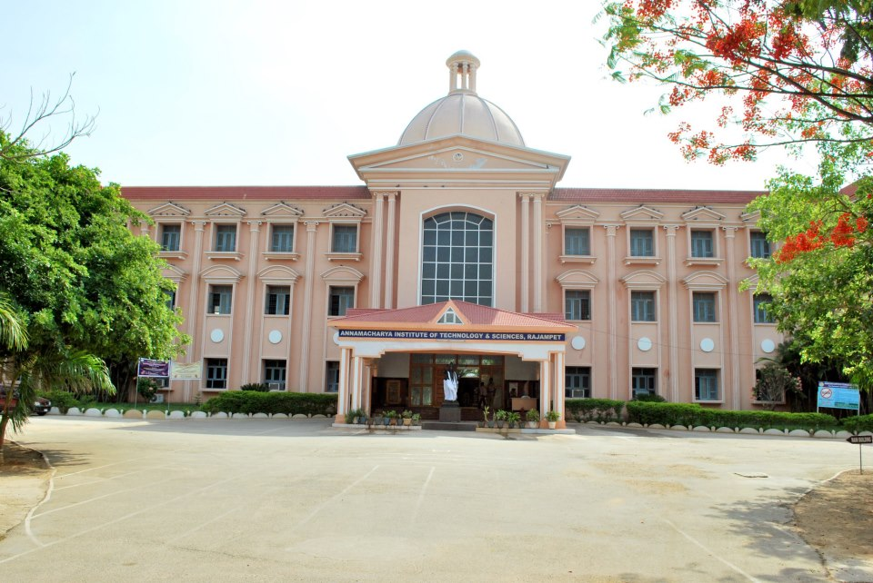
IndIan InstItute of management
Annamacharya
Institute of Technology & Sciences (Autonomous): Rajampet
Managerial Leadership And
Conflict Resolution

Programme Director:
Dr.P.Subramanyam

Programme Dates:
February 27th - March 01st, 2023
Programme Venue:
AITS MBA SEMINAR HALL
Introduction
The Program aims to focus on the following areas:

Module 1: Development of Individual Potential
Through various small group experiences, participants will explore and examine their interpersonal styles, interpersonal transactions and communication processes.

Module 2: Leadership Styles and Management of Conflicts in Groups and Organisations
The second module will focus on learning about one’s leadership styles and group processes. In simulated group situations, participants will get opportunities to identify their own leadership styles and the consequences on other team members and also to develop skills in the management of conflict. Conflict Management runs parallel with Managerial Leadership. Therefore, this module is designed to help participants in: (a) Understanding their own Conflict Management Styles, (b) Diagnosing different conflict situations, and (c) dealing with Conflict in a productive and manageable ways.
Module 3: The Manager as Change Agent
How does the Manager cope with Change? How does he or she participate as a Change Agent in the process of initiating and managing Change? This module focuses on the conditions, values and strategies by which Managers can become responsive to Change.
Pedagogy
Concept sessions, diagnostic instruments, group activity through breakout rooms, and case study discussions.

Who May Attend
The Programme has been specifically designed for executives in Public/Private Sector Companies. A minimum of five years of management experience and the age group 30-50 years is a desirable consideration. Our experience shows that an organisation gets an optimum return from the Programme when it sponsors a team of 2 - 4 senior executives who have direct work relationships and who, on return to the organisation, can draw upon each other’s skills to transfer the learning to the work situation. Although Managerial Leadership and Conflict Resolution is designed for managers from any functional department such as Production, Operations, Finance, Marketing, etc. HRD Managers may find it especially useful.

Programme Director
Dr. P. Subramanyam is a Professor in the field of Finance and has conducted various programs related to Leadership. He holds MBA Degree from Pondicherry University and a Doctorate from Sri Venkateswara University, Tirupathi. He has presented and attended various conferences as Participant, presenter and Rapporteur. He has co-authored case studies and teaching notes that is present at various online sources.
In addition to Dr. Subramanyam, other faculty member(s) with expertise in the areas of Leadership and Conflict Resolution may also teach in the programme.

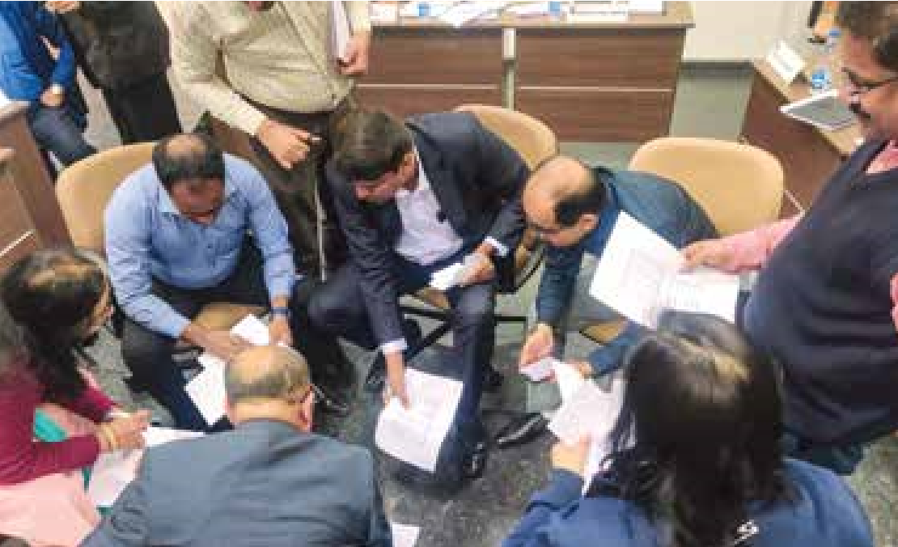
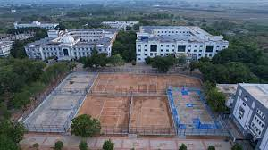
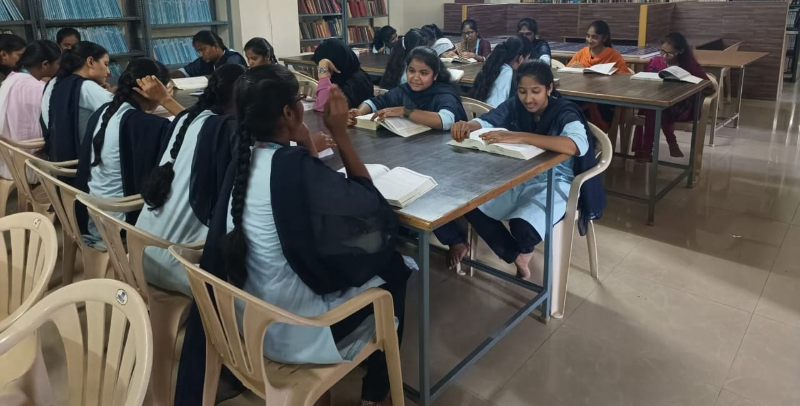
Programme details

Duration:
February 26 - March 01, 2023
Programme Commencement:
9:00 AM on February 26, 2023
Programme Conclusion:
2:00 PM on March 01, 2023
Venue:
MBA SEMINAR HALL, AITS Campus
Accommodation:
For Residential participants

Check in:
February 25, 2023 (6:00 pm onward)

Check out:
March 01, 2023 (2:00 pm)
Programme fees

Residential (R):

4,000

Non-Residential (NR):

2,500
We would strongly encourage candidates to enroll as Residential participants, as the experience of an MDP is optimized in
a full-immersion mode.
Discount on Programme fees:
A discount of 10% on the Programme fees can be availed by an organization if it nominates at least 4 participants for a
particular MDP.
Terms & conditions
•
Participants would have to make their own travel arrangements.
•
Accommodation will be provided till 2.00 p.m. on March 01, 2023. Participants staying beyond this time will have to
bear additional stay and food charges, which they have to settle directly with the hospitality service provider, conditional upon
room availability.
•
Cancellation Policy: In case you/your nominated candidate(s) does(do) not attend the programme, 40% of the programme
fees will be retained, as per policy.

AITS Campus
Small Group Session
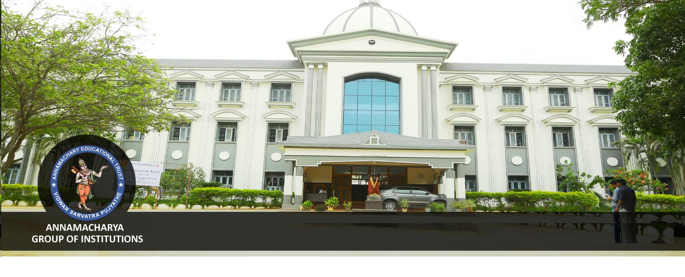
AITS Office

Our correspondence address is as follows:
Annamacharya Institute of Technology & Sciences (Autonomous)
New Boyanapalli, Rajampet, Kadapa (District) Andhra Pradesh
Phone: +251863/251864
www.aitsrajampat.ac.in Pin Co: 516126

For further Clarifications, contact:

Dr. P.Subramanyam, Program Director, Phone number: 7093769885

email id: mlcraits@gmail.com

